- Please copy and paste the image below into your facebook/social media post

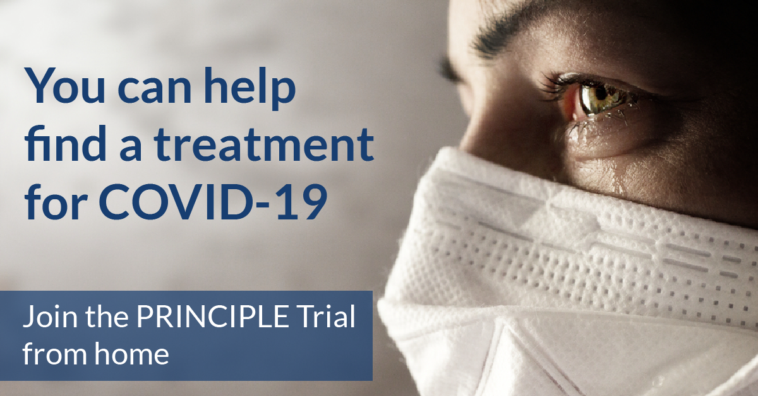
2. Please add the following approved wording (Radio Advert Version 1.0 02.07.2020)

COVID-19 has affected the lives of everybody within the UK and the rest of the world. Finding safe and effective treatments has been the drive of researchers at the University of Oxford and right now, you have an opportunity to help. PRINCIPLE is a national priority trial to find treatments for COVID-19. We are looking for volunteers aged 65 or over, OR aged between 50 and 64 with an underlying health condition.
To be eligible to take part, you must be unwell with Covid-19 symptoms, and have had them for less than 14 days. No face to face visits are needed.
Please help us fight COVID-19 by visiting our website www.principletrial.org

